**East West University**

**Department of Computer Science & Engineering**

**A/2, Jahurul Islam Avenue, Jahurul Islam City, Aftabnagar, Dhaka-1212**

______________________________________________________________________

**Lab Manual : 04(Queue)**

**Course Code : CSE207**

**Course Title : Data Structure**

**Instructor : Tanni Mittra, lecturer, Department of CSE**

**Objective:**

The objective of this lab is togive some basic concepts about QUEUE data structure. After completion of the lab students will know:

* How to create data element in queue
* How to delete data element from queue
* How to perform different operations on queue i.e. copying, compression of string etc.
* Different applications of queue in real life

**Preliminaries:**

A queue or FIFO (first in, first out) is an abstract data type that serves as a collection of elements, with two principal operations: enqueue, the process of adding an element to the collection.(The element is added from the rear side) and dequeue, the process of removing the first element that was added. (The element is removed from the front side). It can be implemented by using both array and linked list.

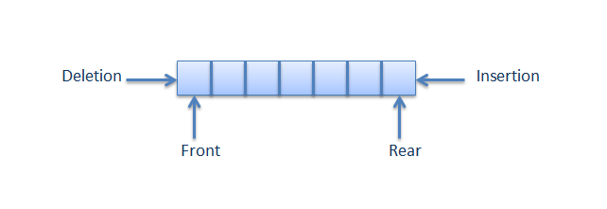Queue is used when things don’t have to be processed immediately, but have to be processed in First in First out order. This property of Queue makes it also useful in following kind of scenarios.

1) When a resource is shared among multiple consumers. Examples include CPU scheduling, Disk Scheduling.

2) When data is transferred asynchronously (data not necessarily received at same rate as sent) between two processes. Examples include IO Buffers, pipes, file IO, etc.

**Lab Task:**

**Exercise 1:**

**CopyQueue**

Write a program that copies the content one queue to another

|  |  |
| --- | --- |
| Input Data | Output Data |
| Q1: 1 2 3 4 5 | Q2: 1 2 3 4 5 |

**Exercise 2:**

**Categorize elements in Queue**

Write a program that creates a Queue and the categorize elements in the queue in such way that numbers less than 18 will be in group1, numbers between 18 to 35 will be ingroup2, numbers between 36 to 45 will be in group3, and number greater that 46 will be in group4.

|  |  |
| --- | --- |
| Input Data | Output Data |
| Q: 12 25 38 45 5 | Group1: 12 5  Group2:25 38  Group3:45  Group4: NULL |

**Exercise 3:**

**Delete all Negative Integer**

Write a program that will take a queue of integers and deletes all negative integers without changing the order of the remaining elements in queue.

|  |  |
| --- | --- |
| Input Data | Output Data |
| Q: 1 2 -3 4 - 5 | Q: 1 2 4 |